2. Project Management Log

**Project management discussion**

The team has worked well this has been evident as all members of Team 3 feel well integrated into the group. The scrum meetings have continued to happen weekly in the lab sessions. The group planning has been good, we have been discussing what each member of the group is doing during these scrum meetings and uploading this to Jira so we know who is doing what. As a team we felt we could of utilised Jira more effectively. We didn’t always log the time taken on a task and not every single task was logged at the correct time which led to this having an impact on the burndown graphs.

The Scrum meetings have been efficient as we have been able to allocate work throughout the group and assign different task to different members. Most weeks all members have been present which has made it easy to discuss issues that have surfaced and resolve them quickly as a group. The meetings have continued to progress at the high the level they were already at before the MVP and there was not much to improve on. During this term we changed the sprints length from 1 weeks to 2 weeks. The increase in sprint time gave the group more time to complete tasks. However the group still feels that due to other module assignments and tests it has prevented us from increasing productivity of the project via more meetings or longer meetings lengths.

There haven’t been many issues with communication during the project due to the use of Jira and the updates we receive via our Email when changes to a task or issue from the backlog has been made by a member of the group. The stand-up meetings held often also made sure the group communication flowed smoothly.

The group used stand up meetings during this project. The stand-up meetings have been effective and help the group progress through the tasks. We would discuss what we had been working on individually, what had been completed and any issues that had come up. The meetings were short and precise, normally around 10 minutes long after everyone had said their piece. The group feels that they are a good way of quickly discussing any issues in person and quickly helping each other come up with resolutions.

**Sprint Burndown Charts**

Week 17-18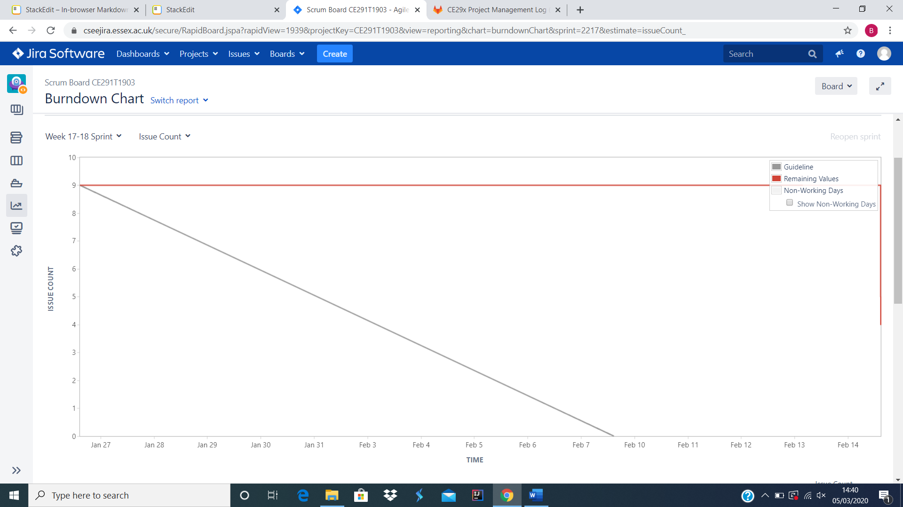

Week 20-21

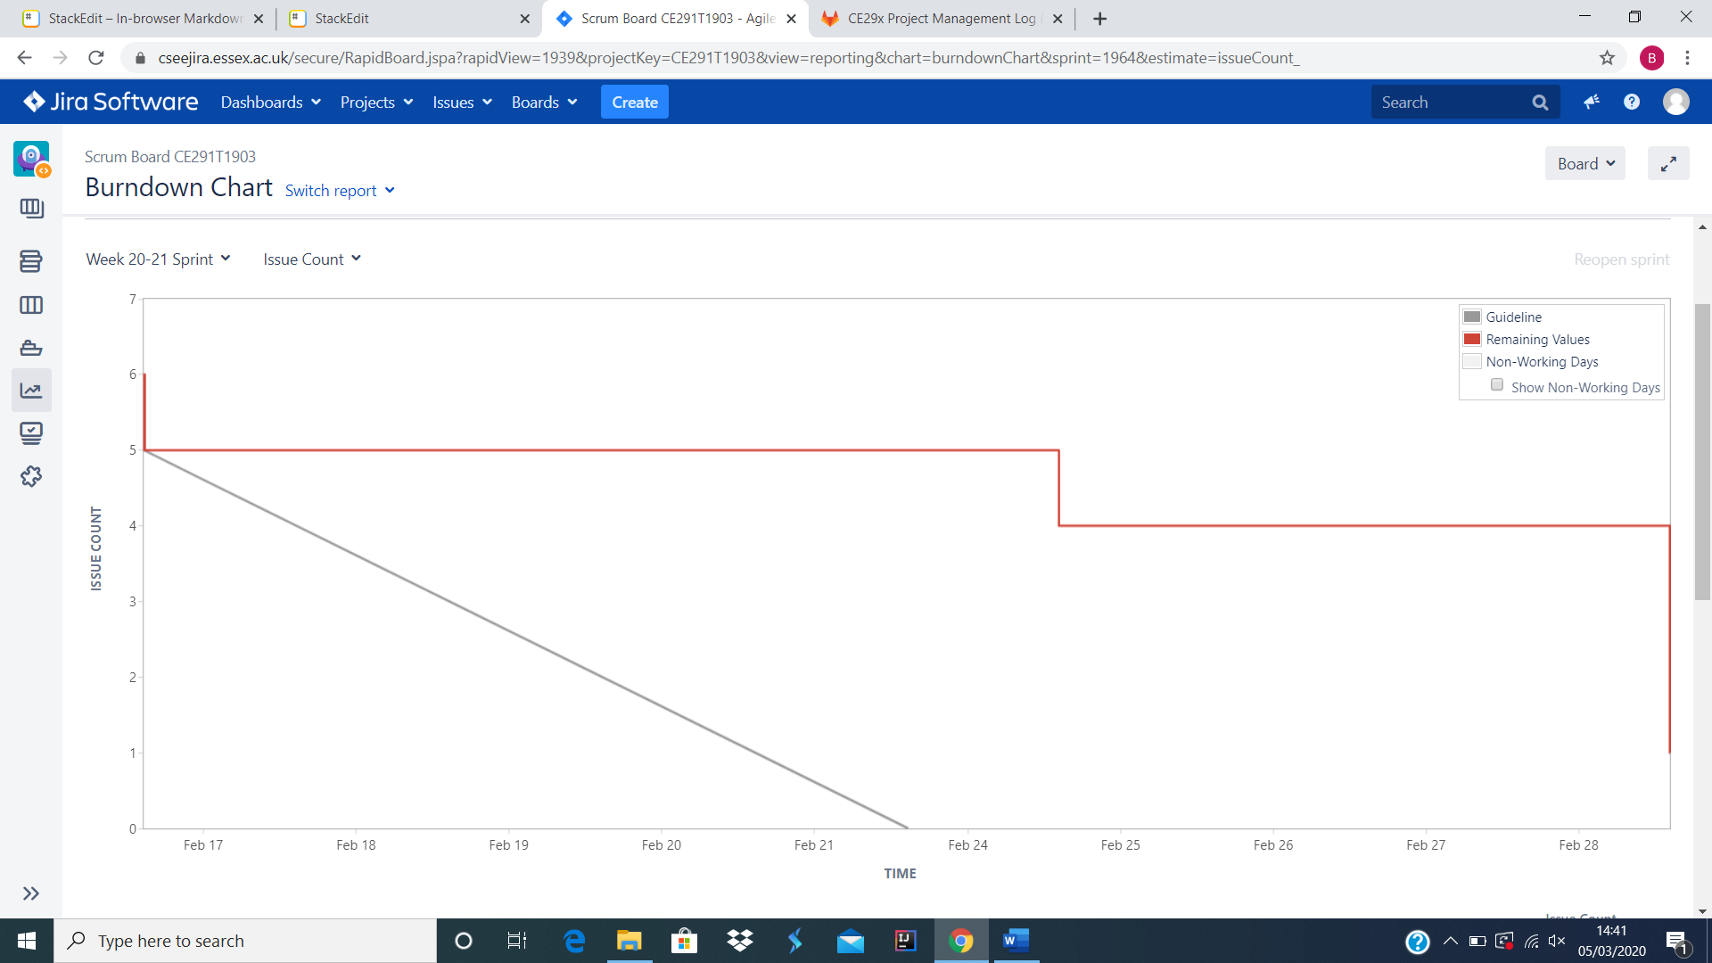

Week 22-23

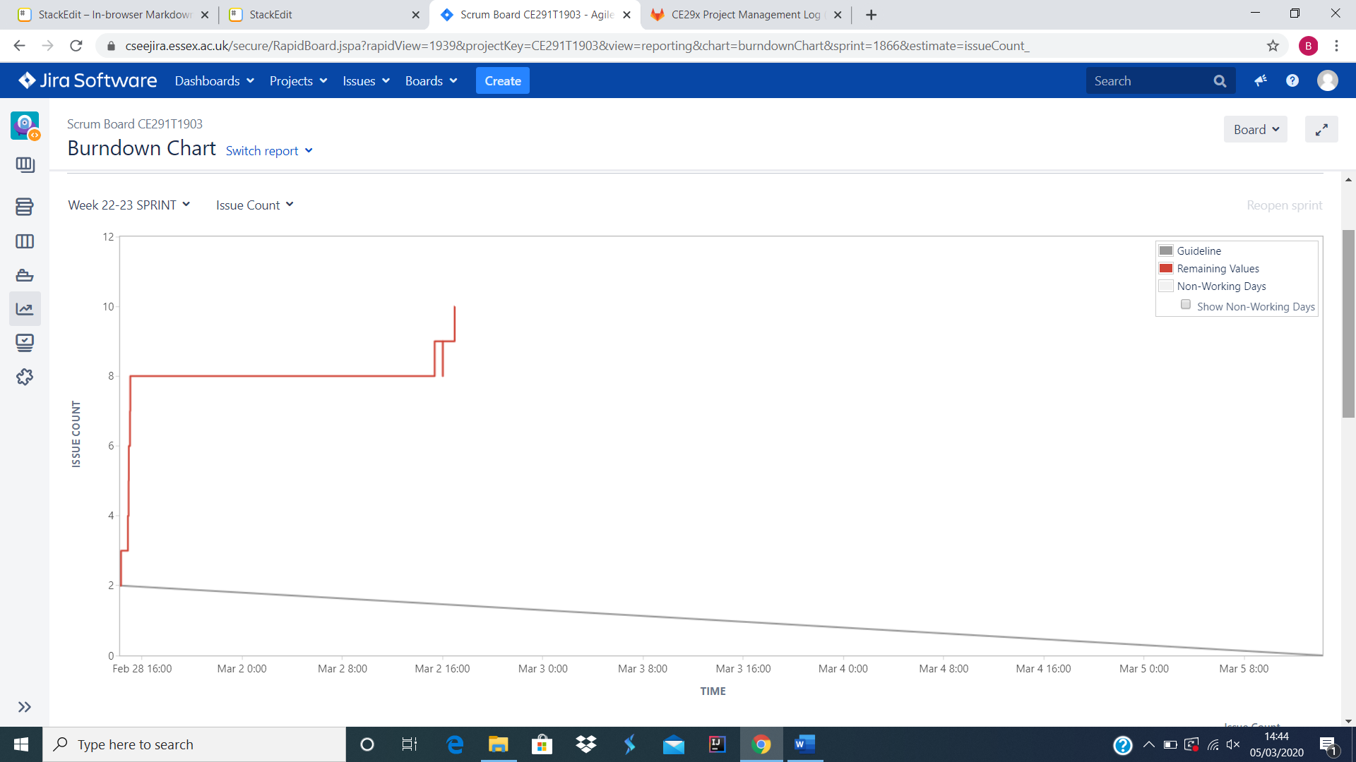

Week 23 (Sprint 2)

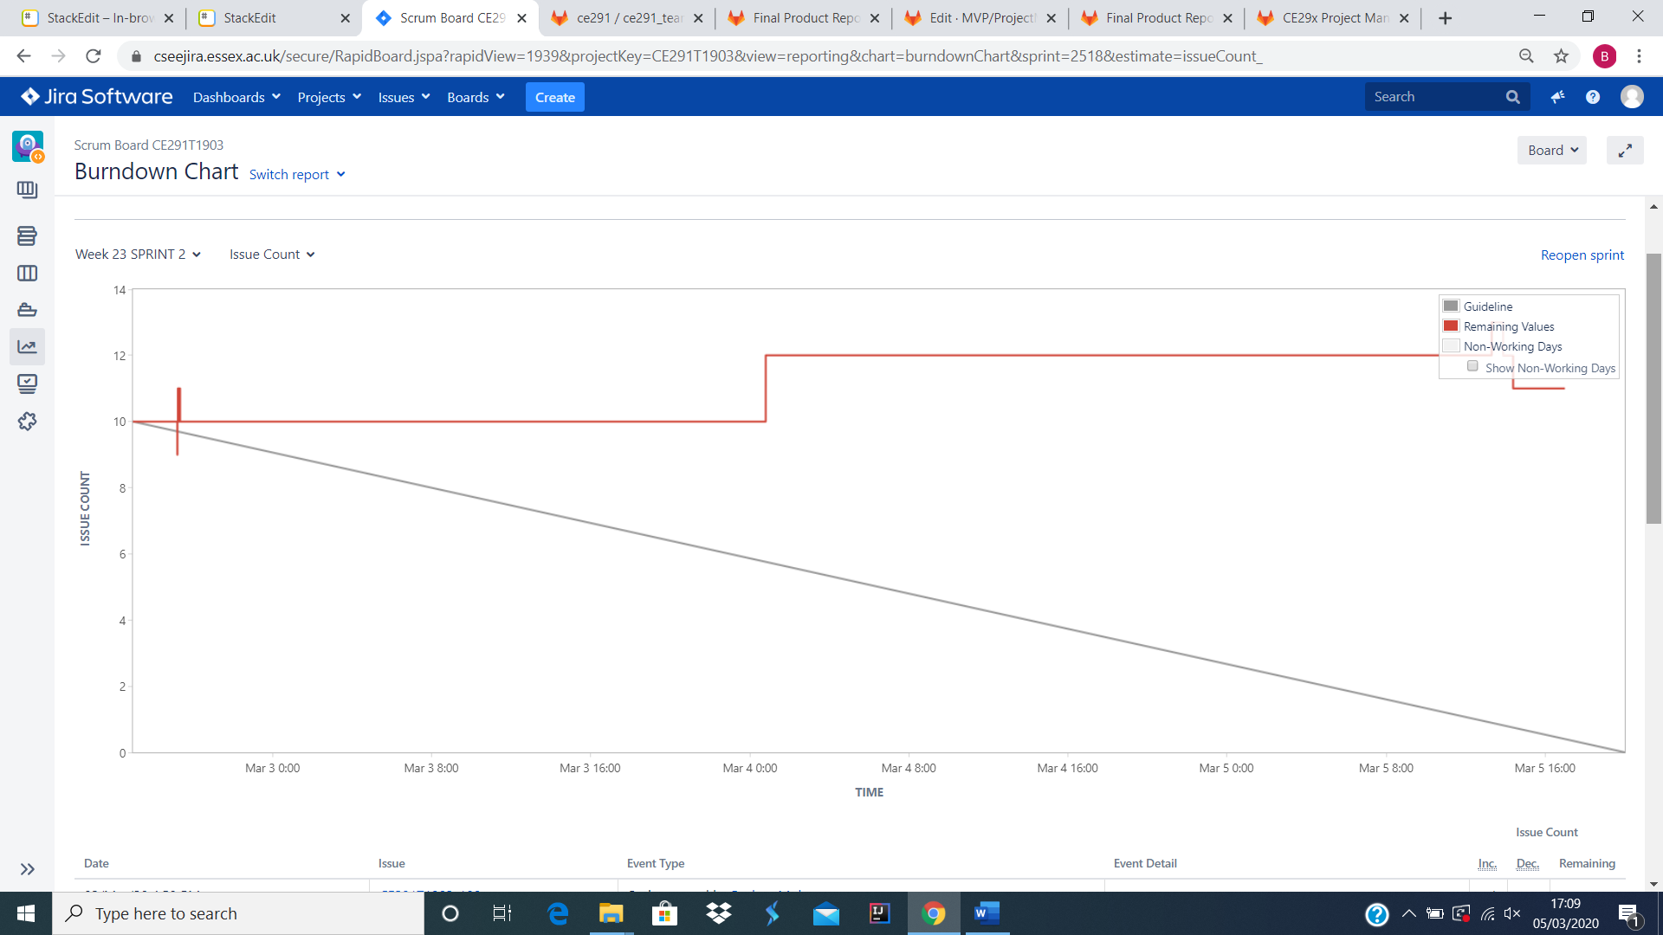

Week 23 (Sprint 3)

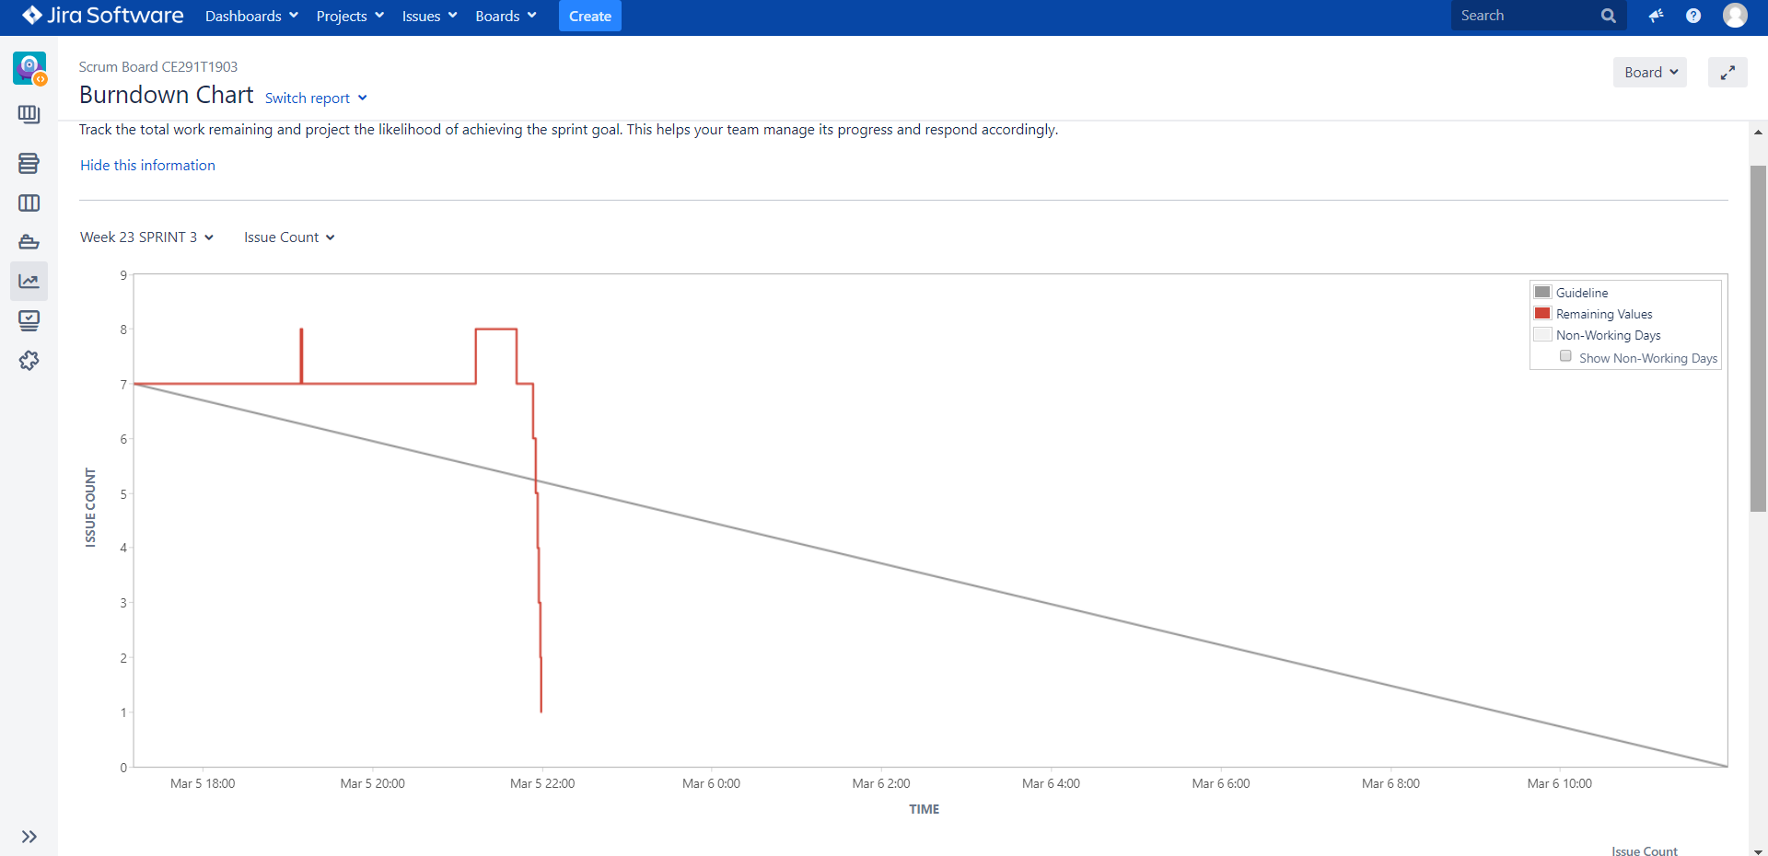

**Burndown-Charts Discussion**

The burndown charts show our progression throughout the project. It shows the amount of issues and the work left during the period of the sprint. You can see the charts issue count going down as the amount of task left is decreasing and they are being marked as done. Many of the burndown charts are inaccurate this is because we didn’t fully utilize Jira as a group. This happened as we didn’t always mark tasks as complete when they were assigned, and some tasks were not added till after they had been done which made the complete date inaccurate. If we were to do this again this is something we would improve as it would make Jira burndown graphs a more accurate representation. Many of our burndown charts start with multiple tasks already assigned this is because they have been carried over from the last sprint to completed in the following one. As the weeks progress closer to the project deadline the issue count increases as more tasks are being discovered that need to be completed for the end product, this can be seen from our screenshots as week 22-23 which is the final week has the highest issue count out of all the burndown graphs. The only remaining issue from the last sprint is the presentation which is due in week 25.

Some stand-up meeting Jira Links:

<https://cseejira.essex.ac.uk/browse/CE291T1903-106>

<https://cseejira.essex.ac.uk/browse/CE291T1903-107>

<https://cseejira.essex.ac.uk/browse/CE291T1903-118>

**Product Backlog**

